Historical pricing testing

Customer Pricing
- Do unit price field in item details modal need to add the same dropdown?
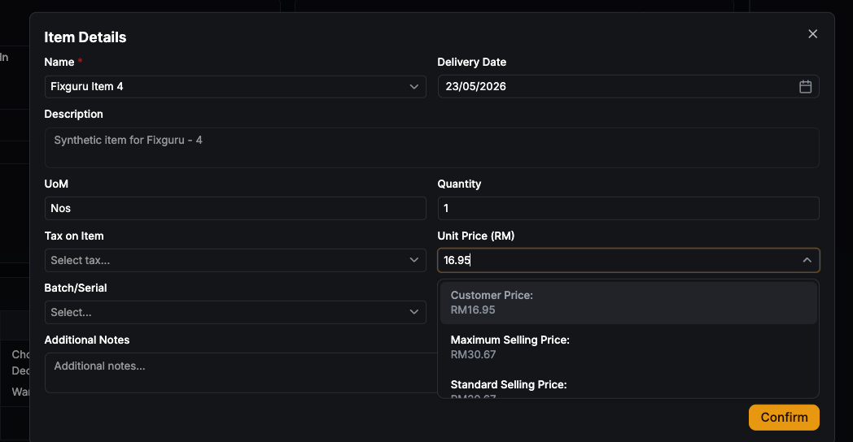
- Is the latest qt price allowed to exceed the max selling price?
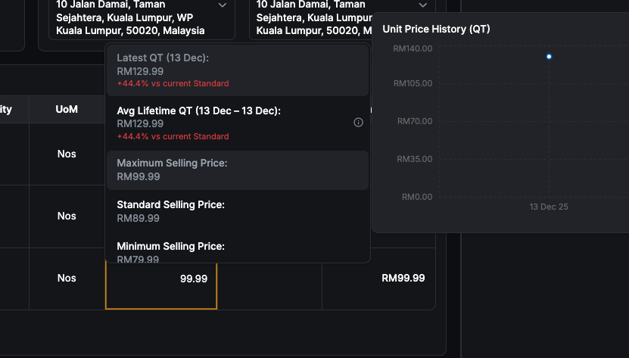
3. Whichever item standard price is 0, it would return the last qtn price and average lifetime price
- Can invoice check historical pricing
- Some items are not getting the last order price

